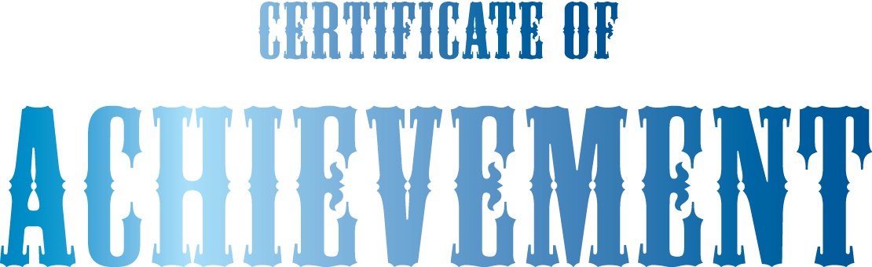
Annie Brown - New York Post

We present this certificate to
Abby Larson
in recognition of outstanding achievement in
Creative Writing
during the 2015 Young Writers Conference

Date

September 24th, 2015

